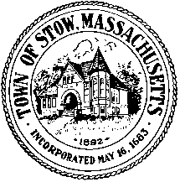
Town of Stow
Local Access Channel Advisory Committee
(LACAC)
380 Great Road
Stow, Massachusetts 01775

October 18, 2018
LACAC Meeting Minutes

Attending: Bob Glorioso, Brian Burke, Lee Pappas, Jonathan Daisy,

7:00 call to order

Minutes
Brian moved, Lee second, to approve the meeting minutes of September 5, 2018. Approved unanimously.

LACAC Board Update
- Brian moved, Lee second to recommend to the Board of Selectmen Robert Putnam as a new member of LACAC, filling the vacancy left by former member Jeff Cronenburg moving to Maynard. The motion passed, 3-0.

HD Conversion
- The Board recommended that Jonathan replace the current Warren room recording set-up to using the Anycast mixer, the expense will be less that the $2000 limit needed for board approval, will consolidate equipment and need less training to operate, as well as be a step toward the HD conversion of Stow TV general practices. The board also approved the purchase of another Anycast if Jonathan thinks it’s needed. The funds have already been approved as a capital expense, are available in a separate account for the purchase.

Brian moved, Lee Seconded, to adjourn at 7:20 pm

Documents submitted
- Warren room conversion proposal from Jonathan
- Expense Quote from Unique Media Systems for configuring the Anycast for Warren room recording.

Respectfully Submitted____________________________________ Date ______________

