Lake Boon Commission
Meeting Minutes
Sep 27, 2023

A meeting of the Lake Boon Commission was held on Sep 27, 2023 at 7:00 pm. The meeting took place by telecommunications using Zoom, because of coronavirus-related state limits on public meetings per the Mar 21, 2020 order of Governor Baker. The meeting was recorded and is available thru Stow TV.

Members attending: Conray Wharff (Chairperson), Dan Barstow (Clerk), Dan Tereau

PFAS statement
• Dan Barstow read the following draft statement about PFAS and Lake Boon, to send to Stow and Hudson Boards of Health. With no edits, Dan T moved, Dan B seconded and we unanimously approved it.

Lake Boon Commission offers its help and support to Stow and Hudson, as the towns analyze and respond to the presence of PFAS contamination for the area in and around Lake Boon. On Sep 20, 2023, LBC considered this topic, based on a presentation by resident Kirk Westphal, who heads the Science Advisory Committee for the Healthy Lake Boon initiative (on Stow TV YouTube https://youtu.be/KYgM2AZbYs4?si=BV4OHrNy9XkpaODx). The presentation included data on PFAS levels in the lake and in tested drinking and observation wells around the lake, data on the presence of PFAS in the nearby Fire Fighting Academy, its flow into the Lake Boon area, and potential impact on health of residents and the environment.

PFAS is not LBC’s formal responsibility, but LBC expresses its concern about this serious issue, and offers help to Stow and Hudson Boards of Health and others working on PFAS issues:

- Provide Kirk Westphal’s detailed presentation and slides
- Share data on lake dynamics from the Healthy Lake Boon Initiative
- Encourage residents to test and treat drinking water, partnering with Lake Boon Association
- Integrate PFAS data into lake models by Healthy Lake Boon Initiative
- Collaborate with Stow and Hudson in other ways that emerge over time

Winter Rules Public Hearing
• We conducted this Public Hearing on proposed winter rules, to improve safety and promote shared enjoyment of the lake. In previous meetings we presented draft rules, solicited public input, and modified the draft. In this Public Hearing, Dan T presented the proposed Winter Rules, summarized as follows:

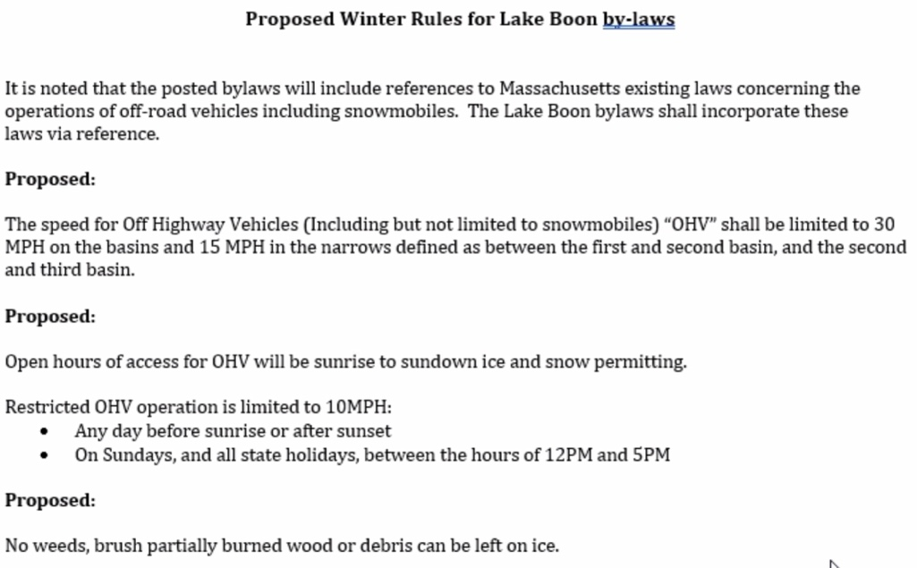
Public comments about the proposal:
• Freddy Dusseault opposed night restrictions on OHV, not wanting to restrict freedom of people use OHV. Dan T responded that we’re not trying to restrict public enjoyment of OHV, but the safety issue is real.
• Bon Cantin supported the proposed winter rules. He also said we should have the rules, even if the police can’t fully enforce.
• Red Aylward asked about a rule prohibiting spinning. Dan T responded that this version does not prohibit spinning, if it is done safely.
• Janet Stiles supported safety rules, akin to safety rules on public roads. If people were driving loud cars up and down the road at night we would complain. Snowmobiles should be no different. She asked about enforcement, suggesting that residents reporting violations should call LBC who in turn would call the police. Conray responded that people should contact the police directly. Dan T responded that rules are an essential starting point, even if the police don’t have resources to fully enforce them.
• James DeWalt wondered if we needed these rules since we didn’t have much ice last year. Conray responded that some winters we have ice, so we will need the rules.
• Dave Siewierski acknowledged varying viewpoints on these issues, but that LBC should use common sense to keep most people happy, without undue restrictions. He supports the proposed rules. Dan T responded to agree with the comment, and that state laws already establish the OHV regulations.

With no further discussion, Dan B moved, Dan T seconded and we unanimously approved the proposed Winter Rules. Dan T will add them into the current by-laws document.

Minutes
• We deferred review of the minutes until the next LBC meeting

Old Business
• Dan B reported that the annual Drawdown will take place on the approved schedule, starting about Oct 15. We will notify residents.

New Business
• Survey of docks needing repair or removal
• Weed treatment update
• Update on Dam repair

Date of Next Meeting
- Nov 14, 2023

Meeting Adjourned:
- Dan T moved, Dan B seconded and we unanimously approved adjourning.
- Meeting adjourned at 7:45 pm

Approved by LBC on Nov 14, 2023
