Lake Boon Commission
Meeting Minutes
Nov 18, 2020

A meeting of the Lake Boon Commission was held on Nov 18, 2020 at 7:00 pm. The meeting took place by telecommunications using Zoom, because of coronavirus-related state limits on public meetings per the Mar 21, 2020 order of Governor Baker.

Members Attending: Kris Krablin (Chairperson), Dan Barstow (Clerk), Conray Wharff (Commissioner)

Meeting Called to Order: 7:00 pm

Public Comment
- Dick Gelpke asked about the status of potential repair work on the dam, and asked if LBC could provide an update. Kris responded that she would investigate with the Selectmen, who have jurisdiction over this matter. Conray said he would forward the most recent planning document.

Meeting Minutes
- We reviewed minutes from Oct 28, 2020. Kris previously gave edits, that Dan. Conray moved, Dan seconded and LBC unanimously approved the minutes.

Bills for Payment
- Although we did not have the latest Solitude bill in hand, we knew the anticipated amount based on the contract:
Stow portion $1,041.67
Hudson portion 520.83
Total 1,562.50
- Dan moved, Conray seconded and LBC unanimously approved payment, assuming the bill when received matches this amount.

2020 Drawdown Activities
- Dan gave an update, that the drawdown is proceeding on the approved and announced schedule, and will be completed by December 1, 2020. He reported that Stow Highway Dept had crafted a half-height board (4”) that enabled the drawdown to take place in weekly steps, of 4” each week.
- Conray mentioned that some residents had commented to him about the timing, wondering if it should start earlier than Oct 15. Dan explained that the recently approved drawdown permit had flexibility, as long as it takes place between Oct 1 and Dec 1. Dan also commented that we will notify residents of the proposed start date 3 weeks in advance, to give them time to prepare.

New Drawdown OOC
- Dan confirmed that we now have confirmed Permits and Orders of Conditions (OOC) for the drawdown, from both Stow and Hudson. They towns concurred on shared language for the OOC.

Boat Maintenance and Winterizing – Discussion / Decision
- Conray explained that the LBC boat has intermittent problems with the engine, and that Robinson Marine will work on the repair, with a cap of $800, as approved in the Oct 28, 2020 meeting
- Kris commented that the lights don’t work on some of the buoys. Conray will look into it.
- No new decision or approval required.

FY21 Budget (Operating & Warrant) – Discussion / Draft
- Kris presented an overview of the current (FY21) and draft new (FY22) budget (see details below).
- Kris noted that we are still on track within our budget, though we did have unexpected expenses for the drawdown permit mailings and newspaper announcements.
- This is a first read of the budget, that we’ll review and discuss in future meetings.
- We discussed the possible need for a capital expense for a new motor for our boat, that might cost up to $15K. This would require a warrant item.
- No voted required at this step of the review.

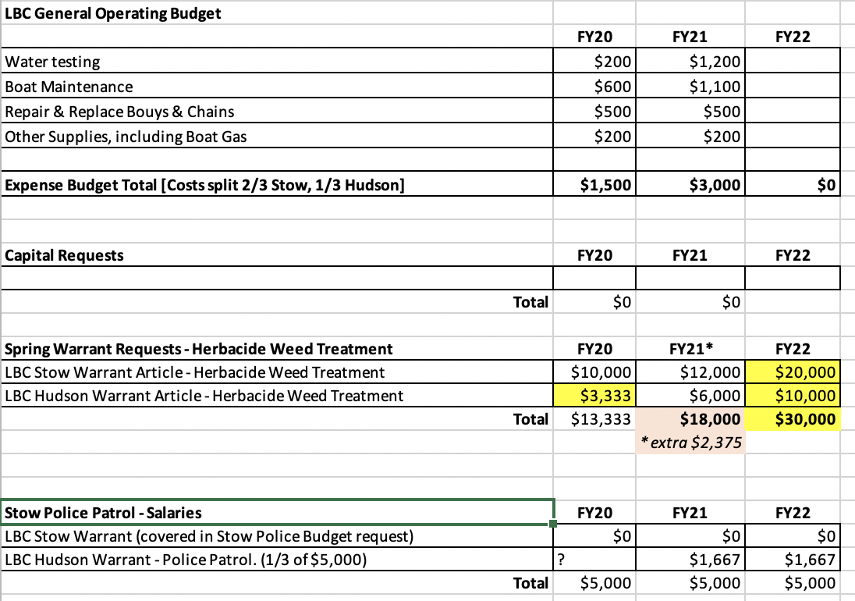

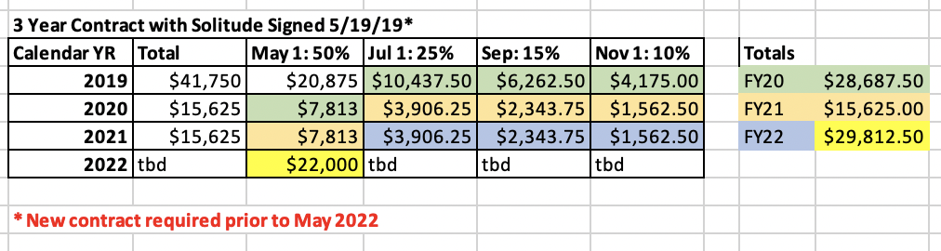

Old Business
- Dan provided an updated on the MVP grant for Healthy Lake Boon project, to assess the health of the lake. The grant for $154,000 was approved by the state. We now have in place the award, through Stow town government. We have begun meetings with town officials, with Stow and Hudson Conservation Commissions and our Steering Committee.

New Business
- Update on plans for the dam repair

Date of Next Meeting
- Tentatively scheduled for Dec 16, 2020, 7:00 pm

Meeting Adjourned:
- Conray moved, Dan seconded and LBC unanimously approved adjourning.
- Meeting adjourned 8:19 pm

Approved by LBC on: _____________________

