– Assessing the Health of Lake Boon –

A Key to Climate Resiliency

in Stow & Hudson, MA – and beyond

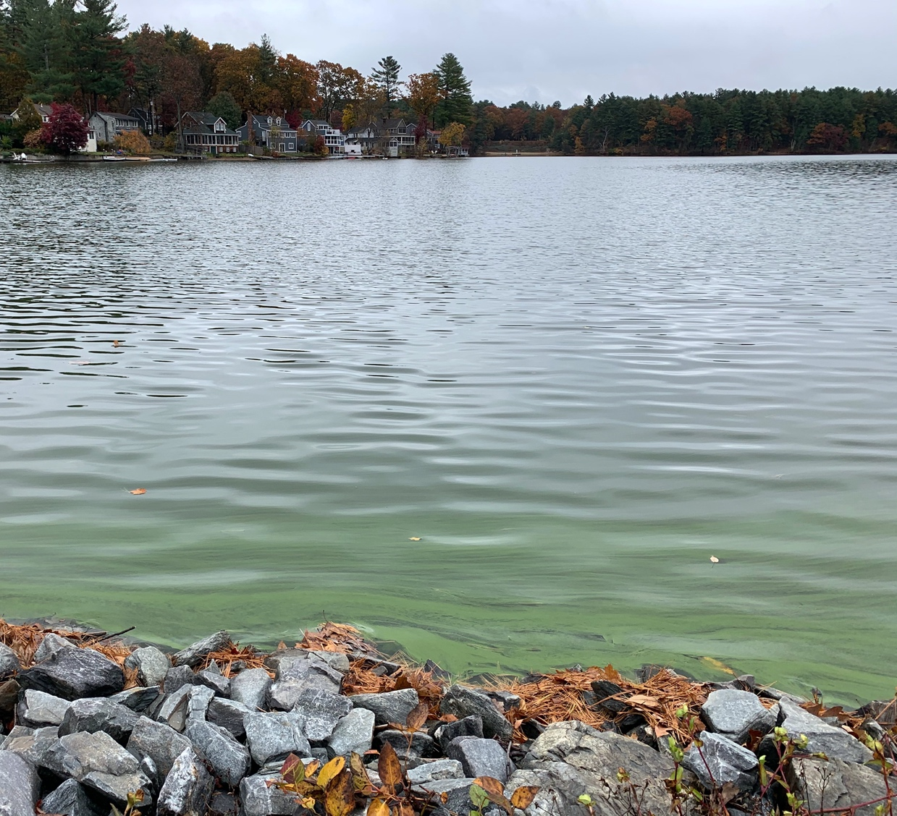

Proposal to MA Municipal Vulnerability Program – Action Grants

Submitted by: Town of Stow MA
In collaboration with Hudson, MA and the Lake Boon Commission

As recommended action from Stow and Hudson Climate Resiliency Planning Grants

June 11, 2020

Municipal Vulnerability Preparedness Grant Program Application Form
RFR ENV 21 MVP 02

1. Municipality: Stow and Hudson, MA

2. Project Title: Assessing the Health of Lake Boon – a Key to Climate Resiliency
in Stow & Hudson, MA – and beyond

3. Type of Project (select one):
√ Planning, Assessments, and Regulatory Updates
  - Nature-based Solutions for Ecological and Public Health
  - Resilient Redesigns and Retrofits for Critical Facilities and Infrastructure

4. Local Project Manager and Point of Contact:
Name: Daniel Barstow
Job Title: Member, Lake Boon Commission
Department/Agency: Town of Stow
Address: 380 Great Rd
Stow, MA Zip: 01775
Telephone: (978) 235-3300 Fax: (978) 897-4514
Email: DanBarstow@gmail.com

5a. Proposed Funding Summary:

 | Grant Request  Amount | Match  (≥25% total project cost) | Total Project  Cost
FY21 | 66,300 | 21,965 | 88,265
FY22 | 87,700 | 30,085 | 117,785
Total | 154,000 | 52,050 | 206,050

5b. Match description:

As detailed in the budget, the 25% match has four components, all confirmed:

- A citizen science-based initiative, where Stow and Hudson resident volunteers will collect a diverse set of measurements and observations, from multiple sites around the lake, on a mostly monthly basis from April to November. Volunteers will use standard protocols for which they will be trained and monitored. Volunteer residents will also participate in developing, reviewing, promoting and implementing whatever proposed remediations emerge from this study. (1,010 hours * $25 = $25,250)
- Steering Committee of 10 people, including experts in climate change and ecosystem science, representative residents, and leadership from local environmental organizations, will donate time and expertise to assure the viability of the study, inclusion of state-of-the-art climate science, and review the nature-based solutions. (100 hours * $25 = $2,500)
- Stow and Hudson town governments and the Lake Boon Commission will not charge for their staff time for operational support. (180 hours * $35 = $6,300)
- Cash contribution by individual residents of both towns, in a fund-raising campaign organized by the Lake Boon Association, because of the merits and importance of this study towards regional climate resiliency. ($18,000)

Special Note: As of May 15, 2020, residents have begun to train and collect some preliminary measurements. This will continue throughout the year to provide baseline data. However, this proposal does not include any of the pre-grant work done before the anticipated start date of October 2020.

6. Project Summary:

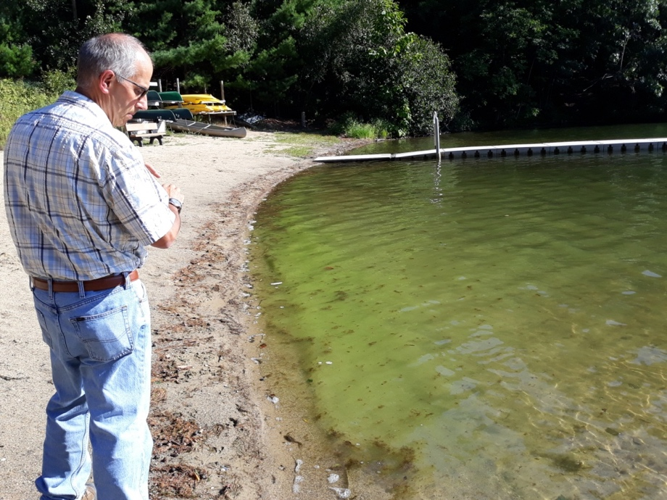

Lake Boon is an essential resource for the towns of Stow and Hudson, MA, and is a key part of the regional watershed and Assabet River system. In their MVP Community Resilience Building Workshop Summary of Findings, both Stow (2018) and Hudson (2019) cited Lake Boon as one of their priority challenges for climate resiliency, since Lake Boon is both vulnerable to climate change and an essential part of the water supply, drinking water and regional ecosystems. Serious climate change related impacts include increased sizable algae blooms and toxic bacteria, most likely from rising temperatures and higher intensity storms, to the extent that the town Board of Health needed to close the lake for several months in the summer of 2019 for the safety of residents. The lake must be protected, through nature-based solutions emerging from a detailed analysis of the lake as an integrated system.
Therefore, this project will conduct a multi-faceted data collection and analysis, based on a scientifically designed set of measurement protocols and a modelling system. With the help of residents as trained “citizen scientists,” the goal of this project is to collect data on nutrients, water flows, aquatic biology and other aspects of the lake’s dynamics, including phosphorus, dissolved oxygen, chlorophyll, conductivity, precipitation, nitrogen, and observations of native and invasive plants growing and decaying, and lab tests for algae and bacteria. The data collection will take place at multiple locations on a daily, weekly or monthly basis, as appropriate. We will then analyze the data using hydrologic and water quality models, which will integrate current and projected impacts of climate change, such as warming temperatures and changes in precipitation and run-off.
Based on this analysis, the project team will create a set of recommendations for consideration by the residents and civic leaders in Stow and Hudson, with a special focus on nature-based solutions. Possible actions could include shoreline vegetation, aeration systems, controlled run-off, public education and support for reduced fertilizer use, changes in the outflow rate through the lake’s weir, limits on new homes, residential septic remediations, as well as other recommendations that may emerge from the analysis. This grant will include public engagement throughout, and lay a solid base for action planning by the towns. However, it does not include actual implementation, which is beyond the scope of this proposal.

7. Stage of Project Implementation
√ a) Assessment, Conceptualization, and/or Feasibility
☐ b) Preliminary Design and Project Planning
☐ c) Permitting and Final Design
☐ d) Construction, Installation, and/or Monitoring

8. Project Location Please provide the address for your project location or the closest addressed location.

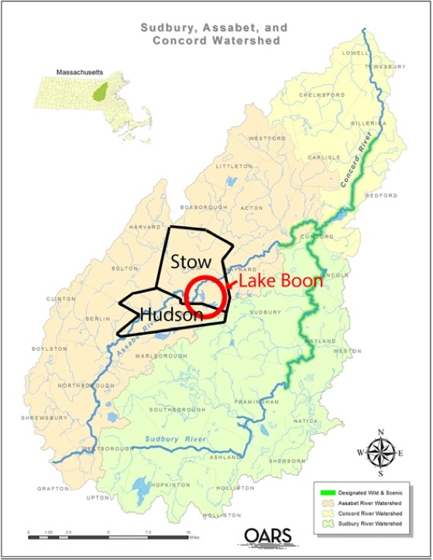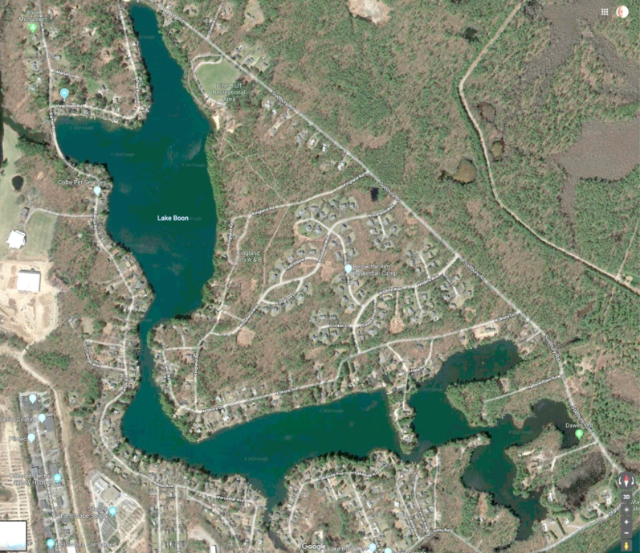
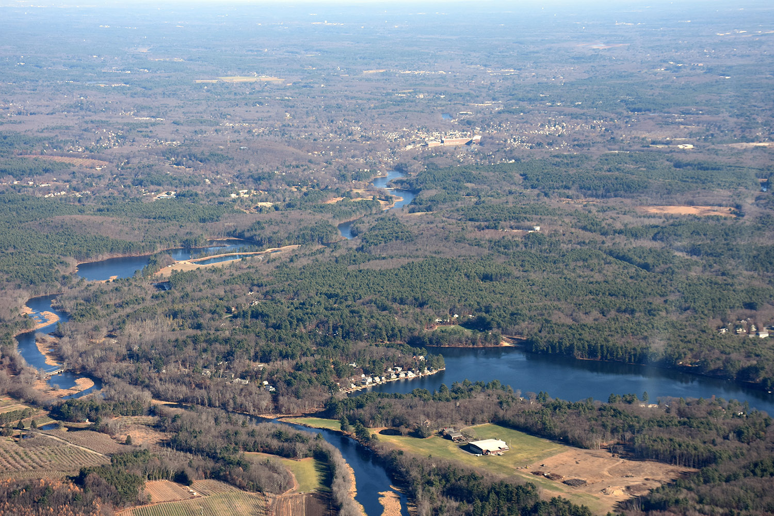
Lake Boon (lower right) outflows into Assabet River system (left and center)

Sudbury Assabet and Concord (SuAsCo) watershed covers a roughly 40 town region. Lake Boon is the largest lake feeding into the Assabet River system. Lake Boon, designated by MA DEP as a “great pond”, is 163 acres, straddling the towns of Stow and Hudson, MA. It is a relatively shallow lake (10’ mean depth), with 4 connected basins. The coordinates of the lake are 42.40° N, 71.50° W. The lake doesn’t have a single address, but communications can be sent through:

Attn: Lake Boon Commission
Stow Town Building
380 Great Road
Stow MA 01775

9.1 Project Description, Rational and Climate Data

Rationale (8 points)

In their MVP Climate Resiliency Planning Grants, both Stow (2018) and Hudson (2019) determined that the quality and quantity of the regional water resources was a high priority for climate resiliency. Water is crucial for residential and business use, for emergency services such as the fire department, for local agriculture, and for the regional ecosystem (Sudbury Assabet and Concord Rivers, aka SuAsCo). The MVP Planning studies concluded that these services and the regional lakes, rivers, aquifers and aquatic systems are all at some level of risk from climate change. This includes increased eutrophication from warmer temperatures and longer ice-free seasons, disruptive run-off from extremes of precipitation and potential flood and drought.
In these MVP plans, Lake Boon emerged as an important focal point for climate resiliency in the region’s water. Lake Boon is the largest lake in these two towns, and an integral part of the regional ecosystem, with a daily average of 1,000,000 gallons flowing into the Assabet River. It is especially vulnerable to climate change.
Over the past few years, Lake Boon has experienced a surprising growth in algal blooms, toxic cyanobacteria and invasive plants. This puts the lake at risk, has led to temporary closures for public access, and the recorded deaths of two dogs. The risk affects the residents’ drinking water, the fire department’s use of the lake for emergency water supply, local agriculture and water-related businesses. Future climate trends such as warming temperatures, increased springtime runoff, and lower summer flows will exacerbate this problem. Regionally, the impact extends further, as the outflow of algae, toxic bacteria and nutrients detrimentally affects the Assabet River and other communities downstream.
Massachusetts has over 3,000 lakes, many of which are finding similar impacts of climate change. As with Lake Boon, many lakes and ponds report increased algae and cyanobacteria and other risks to regional ecosystems and municipal water supplies, with multiple lake closures. This has become one of earliest and clearest risks to climate resiliency in Massachusetts.
Lake hydrology is, in a sense, the canary in the climate coal mine, with compelling evidence that climate change is affecting the state’s lakes and their surrounding ecosystems in ways that will only exacerbate with the predicted steady increase in average temperatures, higher intensity storms and longer ice-free seasons.
The MVP proposal team reviewed the past few years’ observations of growing eutrophication, as well as three prior studies done over the past 40 years. This review confirmed the increased biological activity, and noted some of the actions the towns have already done, such as storm drains for run-off, winter drawdowns for invasive weeds and reduced-cost septic pumping – with only modest success. The MVP proposal team concluded that these studies have been too limited in the types of data collected, and have failed to understand the full dynamics of the lake and regional ecosystems. The studies failed to identify the root causes of the eutrophication (e.g. depleted oxygen releasing phosphates from the sediments, nutrient infusion from local septic systems or fertilizers, increased storm run-offs) and none of the earlier models integrated the impact of climate change. Without this understanding, the towns can’t develop truly effective ways to build climate resiliency in the lake and broader ecosystem.
Therefore, this project will conduct a comprehensive study of Lake Boon and its climate resiliency. This will feature a multi-faceted data collection and analysis, based on a scientifically designed set of measurement protocols and a modelling system. With the help of residents as trained “citizen scientists,” the goal of this project is to collect data on nutrients, water flows, aquatic biology and other aspects of the lake’s dynamics, including phosphorus, dissolved oxygen, chlorophyll, conductivity, precipitation, nitrogen, and observations of native and invasive plants growing and decaying, and lab tests for algae and bacteria. The data collection will take place at multiple locations on a daily, weekly or monthly basis, as appropriate. We will then analyze the data using hydrologic and water quality models, which will integrate current and projected impacts of climate change, such as warming temperatures and changes in precipitation and run-off.
Based on this analysis, the project team will create a set of nature-based solutions for consideration by the residents and civic leaders in Stow and Hudson. Possible actions could include shoreline vegetation, aeration systems, controlled run-off, public education and support for reduced fertilizer use, changes in the outflow rate through the lake’s weir, limits on new homes, residential septic clean-ups, as well as other recommendations that may emerge from the analysis. This grant will include public engagement throughout, and lay a solid base for action planning by the towns. However, it does not include actual implementation, which is beyond the scope and budget of this proposal.
This proposal has strong and broad support from both Town governments and their residents, based on public hearings and reviews. The Towns believe this is a crucial and historic opportunity to:
- understand the integrated dynamics of this essential water resource,
- prepare a reasoned and science-based set of nature-based solutions,
- help manage and sustain the lake as a key part of regional climate resiliency

Lake Boon’s Vulnerability to Climate Change (4 points)

This work is aimed at mitigating existing and documented water quality problems that will only get worse with projected climate trends in New England. The Climate Change Clearinghouse for the Commonwealth (CCCC, at resilientma.org) was cited in Stow’s MVP Planning Study (June 2018) as projecting a 4.37º F increase in average daily temperature by 2050, and 10.94º F increase by 2100 for this region. The number of days above 90º F is expected to increase from 8 days now, to 25 days by 2050 and 76 days by 2100. At the same time, total annual precipitation is expected to increase by up to 6” (13%) by 2050 and by up to 8” (18%) by 2100. While total precipitation is expected to increase annually, it is expected to decrease during the summer and fall, and concentrate in more intense storms in the winter and spring.
The project team will validate these projections with the most up to date climate forecasts from the Northeast Regional Climate Center (NRCC) and NOAA Atlas 14. The project team will then simulate future climate conditions in the simulation models to determine how vulnerable the existing pollution and water quality conditions could be to these climate trends. Theoretically, the following cause-and-effect relationships could pose substantial threats to the future quality of Lake Boon as the climate changes:
• More intense and frequent storm events in the spring can carry more land-based nutrients into the lake at the beginning of the growing season, and also increase erosion and levels of suspended solids in the lake.
• Less rain during the summer and fall will mean slower flushing of the lake (higher residence times, or increased water stagnancy, which enables more algae growth).
•Higher air temperatures in the summer and fall can increase evaporative losses, further slowing the flushing rate and increasing residence time and corresponding algae growth. Hotter air (and hotter air for longer periods) will heat the water, which will further enable more algae growth.
For these reasons, it is vital to understand the full dynamics of the lake, and launch nature-based solutions with an eye toward future conditions, which will almost certainly result in further deterioration of water quality if left unmanaged, now and over the next decades of climate change.

Key Components of the Project

As detailed throughout this proposal, the project has five key components:

1. Active and on-going measurement of phosphorus, dissolved oxygen and other metrics of the nutrient levels and general health of the lake. This will be planned, implemented and managed by a company specializing in water quality monitoring, that will be sourced and selected in year one. It will include focused assessment of various locations around the lake, and use of advanced modeling techniques.
2. Citizen scientists supporting this process, through a coordinated training, data collection and assessment plan, with the results integrated into the analysis done by the aforementioned contractor. Measurements will be collected on a regular schedule from multiple locations around the lake, including water samples, observed algae blooms, invasive weeds and other metrics. We have already recruited over 20 volunteers prepared to do this work.
3. Analysis of the data leading to detailed assessment of the health of Lake Boon, based on a more scientific understanding of the relative sources and impacts of nutrients, and how much more vulnerable the water quality in the lake will be to future climate conditions. This will pinpoint key aspects to deal with in potential remediation plans.
4. Development and public review of recommended action plans, including possible actions such as public education, run-off controls, algicides, septic enhancements, reduced fertilizer, aeration systems, shoreline vegetation controls and so on. This will include a public engagement campaign, a facilitated decision process which prioritizes nature-based solutions, promoting a better understanding among residents and visitors of the lake's health, and building public consensus for appropriate management measures. This grant does not include implementation, but sets the stage for subsequent action.
5. Multi-faceted public engagement, infused throughout the above steps and through a coordinated program of public outreach, education and opportunities for public input. This will include a special outreach to diverse communities in Stow and Hudson, especially lower socio-economic and ethnically diverse populations, and a translation of core outreach materials to Portuguese and Spanish. We will also work with local schools to use this project as a case study in climate resiliency, including the opportunity for students to join in the data collection and analysis.

MVP yearly progress report (1 point)

Stow and Hudson have each submitted their annual MVP progress reports, as follow-ons to their awarded MVP Planning Grants. See Attachment: MVP Yearly Progress Report

9.2 Nature-Based Solutions and Environmental Co-Benefits (18 Points)

Nature-Based Solutions drive this proposal (10 points)

Stow and Hudson endorse nature-based solutions – The towns of Stow and Hudson are both firmly committed to implementing nature-based solutions. Each town has policy statements and action plans that underscore this commitment. All actions that affect the health of the lake must pass wetlands regulations and approval by Stow and Hudson Conservation Commissions, both of which have consistently favored nature-based solutions. Stow’s Planning Board emphasizes environmentally sensitive site design and low impact development and Hudson’s housing regulations have sections on green development and the use of low impact design.
Stow and Hudson Conservation Commissions have formally endorsed this proposal, especially its call for nature-based solutions to maintain a healthy Lake Boon over the long-haul as climate change magnifies certain impacts. Stow and Hudson have already installed new storm drains, discounted septic pumping, and done annual drawdowns – all nature-based solutions for the health of the lake.
Understanding Lake Boon as a natural Ecosystem – Determining the most appropriate nature-based solutions requires a solid understanding of the system and its threats and stressors. As such, the core goal of this proposal is to develop a multi-faceted monitoring plan to gather data on nutrient-loading and algae and cyanobacteria levels in Lake Boon, and analyze this data using hydrologic models, to develop a foundational understanding of the state of the Lake, and incorporate state-of-the-art climate models to anticipate the most likely impacts of climate change. With this information we can better understand lake dynamics, the role it plays in the watershed, and the most appropriate nature-based mechanisms for addressing these environmental threats and stressors.
Authoritative responses to climate change – The models used to analyze Lake Boon as an ecosystem will incorporate current climate projections from multiple studies of climate change and recommendations for nature-based solutions, such as the position paper on Lakes and Climate Change, from the North American Lake Management Society (see Appendix). This authoritative reference on lake management, cites the potential impact of steadily warming temperatures and severe precipitation, and recommends nature-based solutions, such as those listed below.
Potential recommendations for nature-based solutions – At the end of this project we will provide the Towns of Stow and Hudson with a specific set of recommendations for how to maintain and improve the ecosystem health of Lake Boon. Which solutions are recommended will depend on results from data collection, modeling and analysis. The recommendations and scenario-planning will focus on nature-based solutions, such as:
- plantings to create natural shoreline buffer strips
- improved storm drainage systems
- pervious paving options for roads and other surfaces
- rain gardens
- incentives for frequent septic pumping and, in some cases, remediation
- reduced fertilizers, and converting lawns to green gardens
- minimize ground water pumping for irrigation
- public education about all of the above solutions

Implementation for the long-term - These nature-based solutions will be used long term and affect the lake and the larger SuAsCo ecosystem for decades to come. These are not just short-term solutions, since climate change is a long-term challenge. We are fundamentally altering how we understand the lake, how we take care of it, and how we adapt to new metrics, models and insights on the effects of climate change on lake ecology.
Monitoring and supporting the success of nature-based solutions – The Lake Boon Commission and towns of Stow and Hudson will continue this monitoring program in the long-term, beyond the end of this MVP project portion. All partners support continued monitoring, management, and maintenance of any nature-based solutions used.

Environmental co-benefits (8 points)

Lake Boon impacts the large SuAsCo watershed – As noted above, an estimated average of 1,000,000 gallons flow daily, in managed outflow through a weir in the Lake Boon dam, into the Assabet River. Any reductions in the nutrient overload, surface algae and cyanobacteria will in turn help the health of the SuAsCo watershed, and help support climate resiliency well beyond Lake Boon. A healthier Lake Boon, along with the emphasis on nature-based solutions, helps Hudson, Stow and other towns downstream improve water quality, support more environmentally savvy agriculture, prepare for severe storms and drought, and improve and protect wetlands.
Improved wildlife habitats – The lake and nearby river systems are important homes for essential wildlife, such as beavers, otters, muskrats, ducks, geese, swans, osprey, frogs, turtles and a wide range of fish. This includes, for example, the Assabet River National Wildlife Refuge that is directly downstream, within a mile of the Lake Boon outflow. Observers have already reported the negative impact of alga blooms on this habitat, and this will likely get worse with climate change and increased eutrophication unless we act now.
Aquatic habitat in Lake Boon itself – While recent beach closures and alerts have been triggered by public health concerns, the increasing organic productivity is threatening the ecosystem within the lake itself. Already we see oxygen levels declining at lower depths. Effectively controlling nutrient inputs to the lake, especially as the climate changes, will create a healthier lake for both humans and the fish and wildlife who live in and around the lake.

9.3 Environmental Justice and Public/Regional Benefits (14 points)

Environmental Justice Populations (8 points)

Stow and Hudson are committed to equal-opportunity, equitable housing and environmental justice. Although neither town has designated EJ Populations per MA EJ viewer, each does have significant numbers of people with limited resources who will be impacted by climate change, and are part each town’s climate resiliency plans. Hudson, for example, has 7% population below poverty level, and has linguistic diversity with 16% native Portuguese-speakers and 4% native Spanish-speaking. We will translate our core descriptive materials about climate resiliency, Lake Boon and regional impact.
Stow and Hudson both make special efforts to open the lake for recreational use by diverse populations, including local Boys and Girls Clubs who have scheduled access to the Lake Boon town beach. The town beach is used for swimming and picnics by diverse visitors from well beyond the towns of Stow and Hudson. More broadly, the lake is an essential part of the community water resources for towns downstream, regardless of socio-economic level or language. Hence, this program will benefit diverse populations.
We will conduct a three-prong outreach and participation program, to assure we reach and engage all populations:
- Classroom programs on climate resiliency - through presentations in schools and in community organizations about climate change, climate resiliency and Lake Boon as a local focal point of research and action.
- Public meetings in under-represented communities – as we provide multiple pathways for EJ populations to provide input and perspectives. This will include meetings and translations in Portuguese and Spanish.
- Engaged collaborative planning – as we make sure that EJ populations participate in reviewing and helping to shape the action plans.

Broad Community Benefits (4 points)

The most substantive benefits reach well beyond Lake Boon. Both Stow and Hudson identified the quality and quantity of the water resources in their towns as one of the top priorities for climate resiliency. The community’s water resources are crucial for residential and business use, emergency services, local agriculture, and the regional ecosystem. Lake Boon and its direct outflow to the Assabet River are key parts of the Assabet basin and its ecosystem.
Assabet River is on MA’s official list (EPA 303d) of environmentally impaired rivers because of its high levels of phosphorus, which has increased in part because of the impact of higher temperatures on eutrophication. What we do to help Lake Boon reduce nutrients, in turn helps the Assabet and the larger SuAsCo watershed.
OARS, a non-profit organization whose mission is to protect, improve and preserve the Assabet, Sudbury, and Concord Rivers, has endorsed this proposal, and has a representative on the Steering Committee. They will provide clear linkages between our work with Lake Boon and their work with the Assabet and beyond.
The lake is open to the public and used as a recreational resource, often by hundreds of people in the summer, including the neighboring towns of Maynard, Bolton and Shrewsbury.

Regional (2 points)

This project is regional, as a formal collaboration of Stow and Hudson. Both towns received MVP climate resiliency planning grants, and both identified water supply and quality, including Lake Boon, as a priority. This proposal is a direct outgrowth of that process.
This proposal has been endorsed by the respective leadership in each town:
- Lake Boon Commission
- Stow Conservation Commission
- Stow Planning Board
- Hudson Conservation Commission
- Stow Town Administrator

While Stow is the lead applicant and fiscal agent, both towns will work closely together to assure it meets climate resiliency priorities for both towns, and is integrated into future planning and action for climate resiliency in both towns.

9.4 Public Involvement and Community Engagement (12 points)

Assessing the Health of Lake Boon – Public Involvement and Community Engagement Plan
 | Print | Digital | In-Person
Principal Strategies | • Guide to climate resiliency and healthy Lake Boon  • Recommended nature-based solutions | • Web site to enter data and interactively explore  • Online survey regarding potential solutions | • Train & support residents for data collection  • Steering Committee
Assisting Strategies | • Public posting of full analysis report  • Semi-annual report to each town’s governing bodies | • Email semi-annual report  • On-going social media  • All steering committee mtgs as public telecons | • Annual public meeting  • Collaborative Planning for recommendations
Equitable Engagement Modifiers | • Translate guides to climate resiliency and solutions to Spanish and Portuguese  • Posters for visibility campaign | • Web resources for climate resiliency in Stow and Hudson  • linkages with regional environmental orgs | • Broader outreach in Stow and Hudson  • Community liaison  • School speaker program
How community feedback will be incorporated into the project and mechanism by which results will be shared: As detailed below, community feedback is essential. This will take place through public comments in all meetings, on-line surveys and public participation in developing solutions. As detailed below, large-scale distribution of plans, findings and recommendations, including to schools and community organizations, is also planned.

We engage the public in all phases. Our past, current and future commitment to citizen science is central to the short- and long-term success of this project. We have confirmed 20 volunteers to conduct the bulk of the water quality sampling and measurements, 10 citizens to serve on a public steering committee, and a public consensus-building process to identify the most appropriate and sustainable nature-based solutions. Public engagement also includes outreach to the broader communities of Hudson and Stow.
Citizen scientists monitor lake – Stow and Hudson residents will be trained and conduct virtually all measurements and observations of the lake. They will use structured protocols and submit the data through our project web site. This engages them directly in the project, assures reliable and frequent measurements, and keeps the overall costs down because of their volunteer services as citizen scientists.
Steering committee with public representatives – The project will be led by a Steering Committee that includes 10 people from the community, including residents, leadership from both towns, representatives of community organizations and local environmental scientists (see section 9.7 for details).
Public-friendly web site – The web site will provide full information, with interactive engagement, at a level for ease-of-use and ease-of-understanding. This web site will also provide the tools for citizen scientists to enter the data, along with simple displays of results. We will also promote the availability of this information through appropriate Town Dept. social media.
Collaboratively plan solutions – Through a series of public meetings, we will share findings from this study, review potential recommendations and have the public help develop the implementation plan.
Public outreach and education – Supporting all of this, we will do public workshops and education sessions about climate resiliency and nature-based solutions, including school presentations. Our Steering Committee includes the Public Education and Outreach lead for OARS, and a member of the Lake Boon Commission who is a nationally regarded expert in climate education. Lake Boon will be the focus of school presentations on climate literacy, community engagement and nature-based solutions. When CoVID-19 constraints are lifted, students will be invited to join the citizen scientists as they conduct lake measurements.
Translations to Portuguese and Spanish – To assure broad reach, we will translate core materials into the two dominant languages (16% Portuguese and 4% Spanish in Hudson), and do special community-based sessions for those communities.
Linkages with Environmental Organizations – We will work closely with OARS, COLAP and other regional environmental organizations to assure alignment of our goals and action, and share insights from our study.
Full compliance with MVP rules for public engagement – We will follow all the requirements for MVP outreach and engagement, as listed in the RFP, such as clear descriptions, focus on audience, identifying contact people and pathways for public input.

9.5 Project Transferability, Measure Success, Maintenance (6 points)

Transferability (2 points)

Massachusetts has over 3,000 lakes, many of which are finding similar impacts of climate change. As with Lake Boon, many lakes and ponds report increased algae and cyanobacteria and other risks to regional ecosystems and municipal water supplies, with multiple lake closures. This has become one of earliest and clearest risks to climate resiliency in Massachusetts.
Massachusetts Congress of Lakes and Ponds (COLAP) - Hence, our project while localized to the details of Lake Boon, has potential to inform and help other lakes in Massachusetts. We will disseminate our results through COLAP, through their annual workshop and postings to their community web site. This will include our analysis of the impact of climate change, and our proposed nature-based solutions.
MA DEP Water Quality Monitoring Program – We will share our data, analysis, findings and recommendations with the MA DEP Water Quality Monitoring Program. Notably, that program encourages citizen science data collection. Our entire data collection program, including citizen science data, will be carefully monitored, managed and reviewed, based on standard protocols for quality assurance.
Public Website - We will also make the full set of data, analytics, findings and recommendations available on LBC web site (accessible through both Town websites), including both a clear-language summary and a more detailed analysis appropriate for environmental scientists.
Regional Environmental Organizations – We will align our activities with two regional environmental organizations that are directly impacted by Lake Boon, as water outflows into the Assabet River and the SuAsCo watershed. Hence, we will work with the OARS and the SuAsCo Rivers Stewardship Council to share our findings and align our activities and outreach.
MVP Community – Stow and Hudson are already part of the state-wide MVP community, based on each town’s 2018 MVP planning grants. We will engage with other townds and cities that are part of the MVP network, both to learn from their experiences and to share what we’re doing and learning. This cross-MA collaboration with a focus on climate change and municipal resiliency is a key benefit.

Measure Success (2 points)

Our project has clearly defined tasks and sub-tasks, as detailed in our Scope / Budget (Attachment B). Each has defined deliverables and individuals responsible, and will thus serve as the basis for measuring successful completion of each task. Highlighting from that task list, key deliverables are:
- Well-functioning citizen science program to collect data
- Public web site about the project, with a section for data submission and analysis
- Outreach to diverse populations, supporting environmental justice goals
- Steering Committee to provide oversight by scientists, town officials and residents
- Advanced modeling of lake hydrology, incorporating climate change projections
- Annual reports with data findings and recommended nature-based solutions
- Education outreach program
- Semi-annual public meetings to review status and solicit ideas and recommendations
- Semi-annual reviews with town officials and regional environmental organizations
- Share data and findings with COLAP and MA Water Quality Monitoring Program

The Project Coordinator and Steering Committee will measure each of these deliverables based on completion of the task and on the quality of the deliverable. For example, the citizen science data collection has over a dozen specific data types, collected monthly or based on events such as after intense rains – a total of over 1,000 measurements over the two-year project. We will use a well-designed training program and a formal quality assurance program to confirm the quality of the measurements.

Per MVP Requirements, we will submit monthly reports on the 30th of each month, as well as the annual and final reports. Per the guidelines, the final report will describe the study and our findings as a case study and lessons learned that can help other MVP communities. We will report directly to our respective MVP regional coordinators: Stow in Northeast Region thru Michelle Rowden, and Hudson in Central Region thru Hillary King.

Future steps (2 points)

On a deeper level, we will measure our success by our driving goals for this ambitious project. Some of these goals extend beyond the terms of this grant, but are in fact the transcendent goals and metrics of our success:
- caliber of the final report and the insights it provides
- recommended nature-based solutions
- sustainable system for monitoring the health of Lake Boon
- long-term ability to support climate resiliency in managing Lake Boon
- broader impacts in the region
- potential lessons throughout the state

9.6 Need for Financial Assistance (6 points)

Equalized valuation per capita (4 points)
Per guidelines, this analysis will be done by MA MVP program, based on standard valuations for the applicant towns of Stow and Hudson MA

Demonstrated need (2 points)

Over the past 40 years, the towns of Stow and Hudson have done several limited-scale studies of the health of Lake Boon, given the importance of the lake and the persistent challenges of maintaining its health. These included a 1980 Diagnostic Study, 1999 Nutrient Investigation, 2002 Total Maximum Daily Load, 2013 Nuisance Vegetation Study and on-going analysis of algae and cyanobacteria by the Nashoba Boards of Health. While each study has provided important metrics, none of them have assessed the lake on a comprehensive, integrated basis, none have conclusively determined the prevailing causes of nutrient loading and none have dealt with the current and anticipated future impact of climate change.
Simply put, these past studies have been limited by the cost of the type of comprehensive data collection, modeling and integrated analysis proposed here. The towns of Stow and Hudson do not have the resources in their town budgets to support this scale of study. And yet, without this comprehensive analysis, any proposed solutions are unable to target the underlying root causes, and are unable to integrate the growing impact of climate change on the lake. Hence, the financial need is the key factor necessitating this proposal.
We reviewed multiple other potential sources of funding, including those listed in the RFP. These included the EEA Planning Assistance Grants, The MA Land and Water Conservation Fund and the Drinking Water Supply Protection Grant. We considered local foundations that support environmental studies and action plans, such as the Mass Audubon Shaping the Future of Your Community Program. We also looked for potential federal funding – however federal support for climate action has been reduced in the past few years. None of these provided the right match between their priorities and our needs.
The MVP funding is the best programmatic fit, because it acknowledges the growing impact of climate change, supports funding specifically for this type of analysis, and builds on the foundation laid by Stow and Hudson in their MVP Planning Grants. Also, the scope of this project is well within the available funding in the MVP grant budget guidelines.
The total cost has been reduced by the citizen science component in which residents help with the measurements throughout the year, and the direct cash contribution from Lake Boon Association (a membership-based organization of residents).
Thus, this MVP funding clearly addresses a crucial funding gap, without which this essential study and resulting recommended actions would not likely be implemented.

9.7 Project Feasibility, Support, and Management (6 points)

Technical, Financial and Management Capacity (2 points)

This project has clearly defined goals, implementation plan, timeline, budget, deliverables and metrics of success. As detailed below, the project uses a Steering Committee and a Project Coordinator to provide overall leadership and operational management, along with close coordination with town officials from Stow and Hudson to assure project success and integration into Stow’s and Hudson’s MVP Climate Resiliency plans.
Stow is the fiscal agent – Stow received an MVP Planning Grant in 2018, and produced the report which included Lake Boon and a healthy water supply as key goals for climate resiliency. The Town Administrator signed this proposal, and the town administrative staff will handle the financial and contractual elements of this work. Stow Conservation Commission and Stow Planning Board have both unanimously endorsed this proposal, and will coordinate integration of the project work into the town’s climate resiliency actions and related town planning and policies.
Hudson is a formal partner – Hudson also received an MVP Planning Grant in 2019 and also identified Lake Boon and water supply as key goals. Hudson is a formal partner in this proposal. Hudson Conservation Commission has unanimously endorsed it and will lead integration with other Hudson activities for climate resiliency.
Lake Boon Commission leads the application team – The LBC is the ruling body for Lake Boon, established by MA state law in 1941, to regulate the use of the waters of Lake Boon. LBC unanimously approved the proposal, and has overall responsibility for its successful implementation. The lead is Dan Barstow, member of the LBC and 27-year Stow and Lake Boon resident, who has expertise in climate literacy, public engagement and project management.
Lake Boon Association will coordinate citizen science. Not to be confused with the Lake Boon Commission governing body, the LBA, established in 1921, is non-profit (501c3) membership organization open to Lake Boon residents and other interested people. LBA will provide training and coordinate the citizen science component, as residents conduct measurements as defined in the action plan. LBA has experience with a smaller scale but comparable Weed Watcher program, and has identified over 20 volunteers prepared to do this work. The grant budget includes a part-time coordinator for the data collection process, outreach and other project management tasks.
Hydrologic science company (TBD) will do the modeling and analysis. When the grant is awarded, we will prepare an RFP and solicit bids for a company specializing in limnology, aquatic metrics, modeling and climate science. The RFP will comply with MA and state regulations, reviewing applicants for quality, experience and price. This company will manage and implement the technical details of lake measurements, use of multiple models for nutrient analysis, integrate climate data and prepare draft recommendations for remediation. This will include supporting and integrating use of the citizen science measurements.
Steering Committee members oversee and coordinate the whole – The 10-member Steering Committee will meet quarterly to review program details, assure tasks are on track and on schedule, resolve any issues that arise, and guide development of the action plan.
Steering Committee members are:
- Dan Barstow (member, LBC)
- Kathy Sferra (Conservation Coordinator, Town of Stow)
- Pam Helinek (Conservation Agent/Planner, Town of Hudson)
- David Siewierski (President, LBA)
- David Gray (Treasurer, LBA)
- Sandra Grund (environmental scientist)
- Ingeborg Hegemann-Clark (environmental scientist)
- Julia Khorana (OARS board member, Education and Outreach)
- Lauren Bullard (Environmental Science Teacher, Nashoba Regional HS)
- One at-large member will be selected by Stow and Hudson

Letters of Support (2 points)
Stow Town Administrator (fiscal agent)
Stow Conservation Commission
Stow Planning Board
Hudson Conservation Commission
Lake Boon Commission
Lake Boon Association
OARS

Good Standing in the MVP program (2 points)

Stow and Hudson are in good standing in the MVP program. Stow received an MVP grant in 2018, Hudson in 2019. Both completed their Climate Resiliency studies and recommended action plans, with active participation of town residents and experts in community engagement and climate science. Stow and Hudson have both completed their annual progress reports.
This proposal is a direct outgrowth of those MVP Climate Resiliency Plans, and both towns have endorsed this proposal as high priority for both towns. This project is a formal collaboration between the towns.

9.8 Timeline, Scope, and Budget (15 points)

Project Scope (4 points)

This project will assess the health of Lake Boon, integrate projected impacts of climate change, and prepare a set of nature-based recommendations to improve and sustain the health of this essential part of Stow’s and Hudson’s water supply. This program fits into a longer-term strategy for climate resiliency in Stow and Hudson. The remediations and adaptations recommended here will become the foundation for future action, and the citizen science program will continue annually for the long-term, to monitor the success of the proposed remediations.

The project has well-defined scope and deliverables, as detailed in the Attachments (Budget / Scope and Work Plan Outline) and in Section 9.5 above. These deliverables were developed and agreed on by the proposal development team, with representatives from both towns, scientists and regional environmental organizations:

- Citizen science program to conduct measurements for that data system
- Comprehensive set of data on the nutrients and health of the lake
- Integration of the data into hydrologic models
- Use of state-of-the-art climate projections in the data modeling
- Analysis of the lake’s nutrient loading systems and impacts of climate change
- Recommendations for short and long-term nature-based remediations
- Multi-faceted public engagement program, with education & collaborative planning
- Web site for public information, data submission and graphic displays
- Present findings to environmental organizations and climate-impacted lakes in MA
- Local reviews and integration into town climate resiliency plans

At the heart of the project are detailed measurements of the health of lake, to help understand and mitigate the short- and long-term effects of climate change on the lake. This list was developed by specialists in hydrology, lake dynamics and related monitoring techniques. The final list will be reviewed when we post the RFP for a company to do this work, but this list has been vetted for its ability to provide a detailed and comprehensive picture of the health of the lake and the potential impact of climate change.
As a direct outgrowth of planning for this proposal, volunteers have already begun doing some of these measurements, prior to getting the grant, and will continue doing a set of these measurements after the grant (these are not part of the cost-sharing as they take place before the award). They lay an essential base for comparison with the more comprehensive data collection funded by the grant.

Measurement type | Frequency | Locations | LBA has begun unofficial measurements prior to grant
Total Phosphorus | Monthly | 12 | yes
Dissolved Oxygen profile | Monthly | 12 | yes
Temperature profile | Monthly | 12 | yes
Conductivity | Monthly | Perimeter of lake | yes
Chlorophyll-a | Monthly | 4
Phycocyanin | Monthly | ?
Nitrate | Monthly | 6
Ammonia | Monthly | 6
TKN | Monthly | 6
TSS | Monthly | 6
Secchi depth | Monthly | 4 | yes
Cyanotoxin | Monthly | 4
Precipitation | Every storm | 1 | yes
Outflow | Every other day | 1 | yes
algae blooms | As found | Where found | yes
Cyanobacteria | As found | 4
Sediment Phosphorus | Annual | 4

Timeline (4 points)
This is a two-year project, in the following phases. Some components, e.g. steering committee oversight and public engagement, take place throughout.

Fiscal 2021
Oct-Dec 2020 – Launch project – establish steering committee, select hydrologic science company, start public engagement
Jan-Mar 2021 – Plan details – Full details of measurements, contracts with labs, sampling kits,
train citizen scientists, set up web site
Apr-Jun 2021 – Start measurements – Per detail above conduct weekly, monthly and event-
related measurements, submit to data system, review for accuracy, outreach to schools
Fiscal 2022
July-Sep 2021 – Complete measurements – complete the full set of measurements, prepare
climate data for use in models
Oct-Dec 2021 – Analyze data models – integrate all data into models, analyze for root cause(s)
of nutrient loading, project impact of climate change
Jan-Mar 2022 – Prepare recommendations – based on root causes, identify top priority nature-
based solutions, review with towns and steering committee
Apr-Jun 2022 – Public review – Engage residents, broader public & under-represented
communities to review, revise and prioritize proposed solutions, finalize plan

Regulatory Components (3 points)

This project has been fully vetted and approved by the towns of Stow and Hudson, including endorsement by the Stow and Hudson Conservation Commissions. It is in compliance with the rules and regulations of the town and the Lake Boon Commission, which has also approved it.
It has no construction components, so it does not require Attachment C.

Budget (4 points)

The scope and budget are detailed in Attachment B, which presents each task, person(s) responsible, cost and project year. In brief:

FY21 | 66,300 | 21,965 | 88,265
FY22 | 87,700 | 30,085 | 117,785
Total | 154,000 | 52,050 | 206,050

Total Budget

Year One Year Two Total
Grant request: 66,300 87,700 154,000
Cost-sharing (25%): 21,965 30,085 52,050
Project total: 88,265 117,785 206,050

Major costs:

Project Coordinator: 18,000
Hydrology analytics company: 115,000
Lab fees: 39,000
Citizen Science (volunteers): 25,250
Steering Committee (volunteers): 2,500
Stow and Hudson town staff (donated): 6,300
Total 206,050

In terms of the cost-sharing match, the Lake Boon Association will contribute a cash donation of $18,000, plus the value-equivalent of the volunteers doing estimated 1010 hours, making over 1,000 measurements, samples and observations. The Towns of Stow and Hudson also contribute the time of the town staff to support the project and assure its full integration into each town’s Climate Resiliency action plans. The 10-person Steering Committee also donates its time. All of these cost-sharing commitments are confirmed in the letters of support.
The cost of this project, while cost-effective, is beyond the scope of Stow’s and Hudson’s local budgets. The towns have supported smaller scale studies and some modest solutions to maintain the lake health and its climate resiliency. However, these have been inadequate, and the problem of eutrophication continues to grow with warmer temperatures and extreme precipitation events. As detailed above, the only real solution is for a comprehensive analysis of the lake, integration with climate models leading to deeper understanding of lake dynamics, the regional water supply and ecosystems and thus a set of recommended nature-based solutions.
Yet the real value emerges as insights help other climate-impacted lakes in MA. As noted above, there are over 3,000 lakes in MA, many of them have reported growing eutrophication, alga blooms, cyanobacteria and invasive species – akin to Lake Boon. If our detailed study, findings and recommendations shed light on the broader challenges of climate change and lake health management, this will be a smart investment by the MA Municipal Vulnerability Program. Thank you for considering this important proposal.

